- Select the Driver_Loader.exe and click the right button of the mouse.
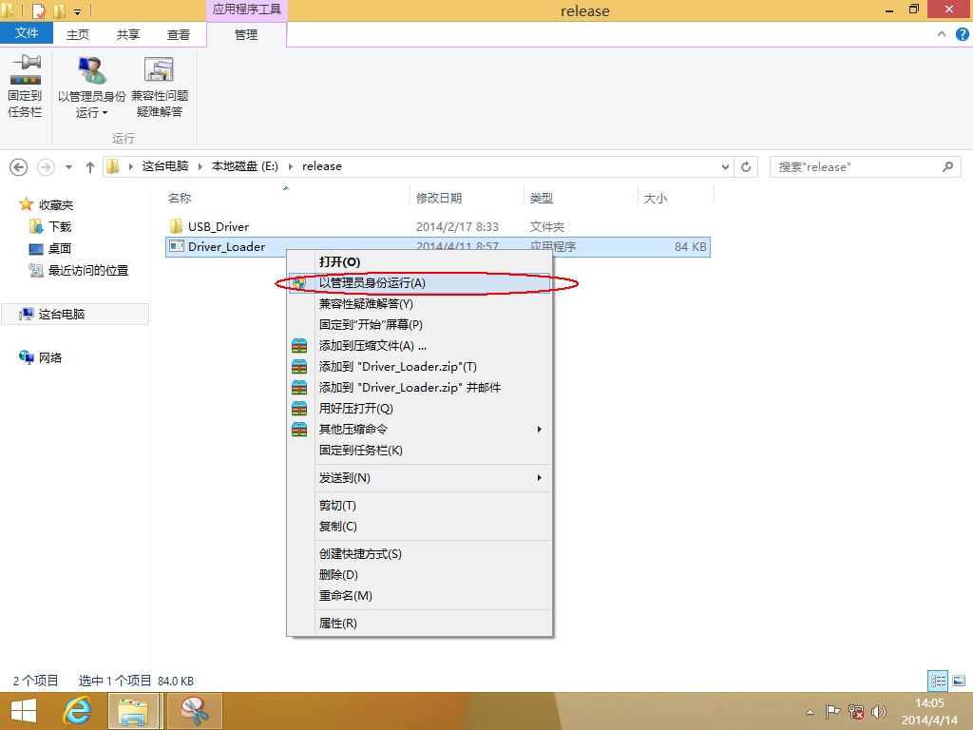
Please select the second item(Administrator run it)
2. Please select YES as below:
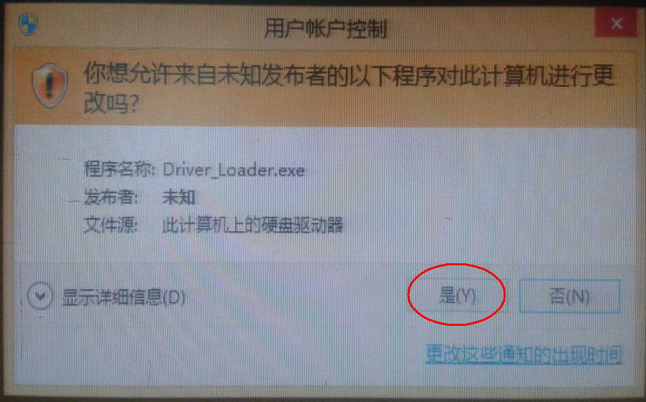
3.Please select the second item(Always set up the driver and run it)
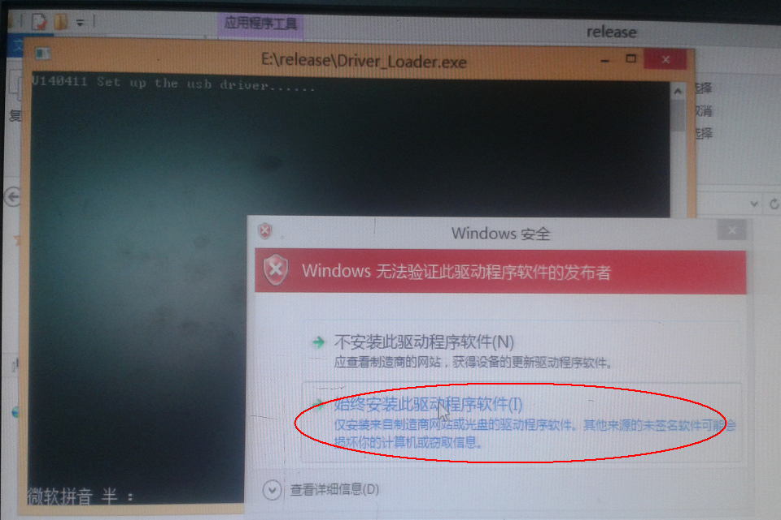
4.The below means that set up the driver successfully.
